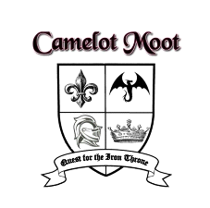Camelot Moot 2023
Registration Form
June 2-4 at Camp Samac

All participants attending are required to be registered with Scouting or Guiding. Registrations received by May 28th will receive a $4 discount per person. Camp is open to any Member aged 14+ as of June 2nd.

Further details are available on Facebook by Camelot Moot page/event or on rovering.org. If you have any questions, comments, or concerns please contact us via email at camelotmoot@gmail.com

Group Name:
Area:
Council:
Scouting or Guiding:
Estimated time of arrival:
Estimated time of departure:

How many Advisors / Leaders: |  | $26 before May 28, $30 after May 28
How many Youth:
Total attending as participants: |  | x _____ | = (amount for cheque)
 |  | N/A

Contact information | Adult Advisor / Leader | Second Member
Name:
Address:
City:
Province / State:
Postal / Zip Code:
Phone number:
Alternate phone number:
Fax number:
Email address:
Please make cheques payable to: "11th Whitby Rovers"

